**New York University Tandon School of Engineering**

Biomedical Engineering  
Applied Mathematics and Statistics for Biomedical Engineering

Fall 2021  
Professor Mirella AltoeTuesday 5:00-7:30PM Rogers Hall 325

**Computer Lab Assignment #1**

**QUESTION 1:** Male fireflies of the species *Photinus ignitus* attract females with pulses of light. Flashes of longer duration seem to attract the most females. During mating, the male transfers a spermatophore to the female. Besides containing sperm, the spermatophore is rich in protein that is distributed by the female to her fertilized eggs. The data below are measurements of spermatophore mass (in mg) of 35 males (Cratsley and Lewis 2003). These data are also available at <https://whitlockschluter3e.zoology.ubc.ca>.

. 0.047 , 0.037 , 0.041 , 0.045 , 0.039 , 0.064 , 0.064 , 0.065 , 0.079 , 0.070 , 0.066 , 0.059 , 0.075 , 0.079 , 0.090 , 0.069 , 0.066 , 0.078 , 0.066 , 0.066 , 0.055 , 0.046 , 0.056 , 0.067 , 0.075 , 0.048 , 0.077 , 0.081 , 0.066 , 0.172 , 0.080 , 0.078 , 0.048 , 0.096 , 0.097

1. **Create a graph depicting the frequency distribution of the 35 mass measurements.**

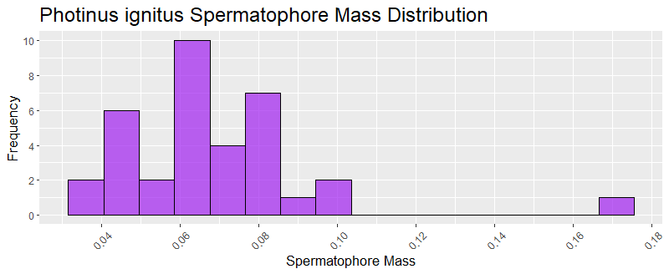

1. **What type of graph did you choose in part (a)? Why?**

I chose a histogram because our goal is to visualize the frequency of each spermatophore mass (continuous data).

1. **Describe the shape of the frequency distribution. What are its main features?**

The frequency distribution resembles a bell curve! Values are clumped around the the middle, with the exception of a single outlier value on the rightmost side of the figure.

1. **What term would be used to describe the largest measurement in the frequency distribution?**

Did you mean the most frequently occurring measurement? If so mode.

If you mean the largest numerical measurement in this specific frequency distribution, then it is an outlier.

**QUESTION 2:** Examine the accompanying figure, which displays the percentage of adults over 18 with a “body mass index” greater than 25 in different years. Body mass index is a measure of weight relative to height.

1. **What is the main result displayed in this figure?**

The percentage of adults over 18 with a BMI of greater than 25.

1. **Which of the four principles for drawing good graphs are violated here? How are they violated?**
2. *Make patterns easy to see.*

Just by looking at the figure, it is difficult to tell what kind of information it is trying to convey. Each bar is red/cut off at different points, regardless of its value for the year + a white triangle (or arrow?) that transitions to grey as the percentage (seemingly? Or maybe it becomes gray over time?) increases.

1. *Draw graphics clearly.*

There are no labels on the figure itself.

1. **Redraw the figure using the most appropriate method discussed in this chapter. What type of graph did you use?**

Since we are graphing data over time, a line graph is most suited.

